**DB connection research-B connection research 31/10/23**

Microsoft Visual C++ Build Tools are required for building and compiling Python packages that contain C or C++ code, which is often the case for packages that interface with external libraries or systems, like database connectors.

***Database Connectors***: Packages like **cx_Oracle** are connectors for Oracle databases. These connectors require compilation to create the interface between Python and the Oracle database system

By installing Microsoft Visual C++ Build Tools, you provide the necessary tools and libraries that Python packages may need to build their native extensions, ensuring that they work correctly on your system. It's a common requirement for many packages, especially those that interact with external systems or databases.

Link: <https://visualstudio.microsoft.com/visual-cpp-build-tools/>

### The connection string has the following format: username/password@host:port/service_name.

> connection = cx_Oracle.connection("KRA-INT/P@ssw0rd@10.40.100.68:1521/dwb02")

#Create the Oracle Database connection URL

#connection_uri = f"oracle+cx_oracle://{username}:{password}@{host}:{port}/{service_name}"

***Dev details***

***username***: INSIGHT

***password***: insight

***Host***: 10.30.100.62

***service_name***: DBM02

The connection below is connecting to dev

-----connection_dev = cx_Oracle.connection_dev("INSIGHT/ insight @ 10.30.100.62:1521/ DBM02")

**Errors**

1. 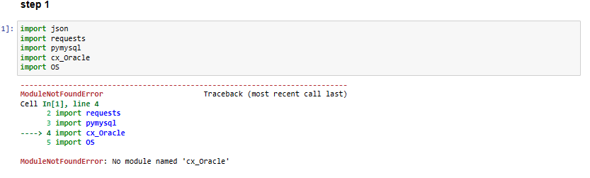
2. 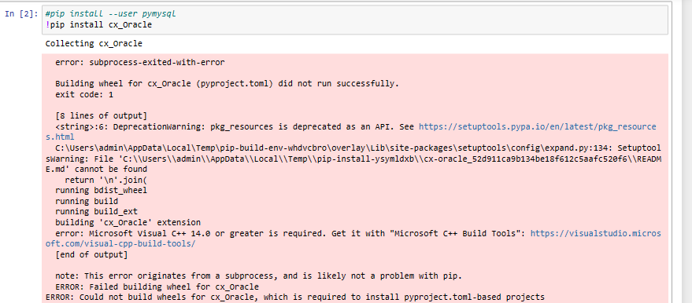
3. 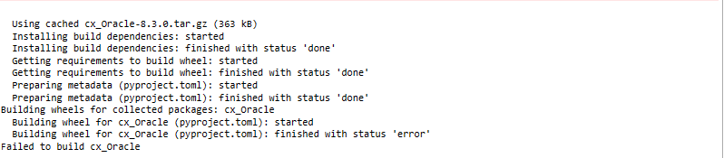

**Microsoft Visual C++ components to download-*NOT RELATED TO PROJECT BUT TO LEARN***

To determine which components you need when installing the Microsoft Visual C++ Build Tools, you should consider the specific development requirements of your projects. The components you need may vary based on the programming languages and libraries you plan to work with. Here's a general guideline to help you decide:

1. **Desktop Development with C++ (Required):** This is typically a core component that includes the C/C++ compiler and libraries. You should select this component.

2. **Universal Windows Platform (Optional):** If you are developing Windows apps using C++, you may need this component. Select it if you are developing Windows Store apps or other Windows-specific applications.

3. **.NET Desktop Development (Optional):** This component is for .NET desktop application development, and it includes libraries and tools. Select it if you are working with .NET applications.

4. **Game Development with C++ (Optional):** Choose this component if you are developing games with C++. It includes DirectX and other game development tools.

5. **Desktop Development with Java (Optional):** This component is for developing Java applications with C++. If you are not working with Java, you can skip it.

6. **Node.js development (Optional):** This component is useful if you are developing Node.js applications with native C++ addons. If you're not using Node.js, you can skip it.

7. **Mobile Development with C++ (Optional):** If you are developing mobile applications (e.g., Android NDK development) that require C++ components, select this option.

8. **Linux Development with C++ (Optional):** This is for cross-platform development targeting Linux. If you're only developing for Windows, you can skip it.

9. **Azure Development (Optional):** Select this component if you are working on projects related to Microsoft Azure.

10. **Python development (Optional):** If you are using Python for development and need to build Python extensions that involve C++, select this option. It can be useful for working with Python packages that require C or C++ code compilation.

Keep in mind that you don't need to select all components, and your selection should be based on your specific project requirements. For most general-purpose C++ development, "Desktop Development with C++" is typically the essential component. If you later find that you need additional components, you can run the installer again and modify your installation.

It's essential to have a clear understanding of your development needs before making component selections, as installing unnecessary components may consume additional disk space and may not be required for your projects.